**Fresher’s Telecom Test Paper**

**Exam Date: 18/02/2021 Total Marks: 20**

**Name: SUNKI ARAVIND Duration: 45 min**

Below figure depicts the telecom network between exchange to customer premises and their explanation is also given. Read the given information thoroughly and answers the questions.

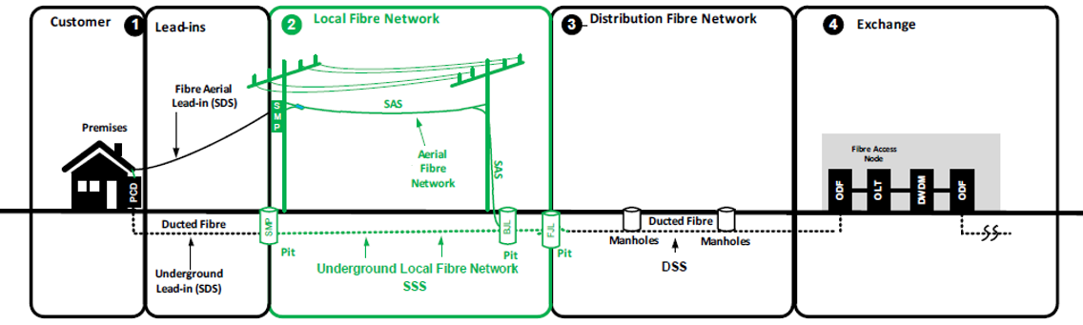

**Glossary:**

FJL - Flexible Joint Location DSS – Distribution Segment Sheath

BJL – Breakout Joint LocationSSS – Splitter Segment Sheath

SMP- Splitter Multiport SAS – Splitter Aerial Sheath

PCD – Premises Connection Device SDS – Service Drop Segment

ODF – Optical Distribution Frame OLT – Optical Line Terminal

**Network Types: OSP/ISP**

The end to end telecommunications network from exchange to customer/subscriber has been classified as Outside Plant (OSP) and Inside Plant (ISP). All the network starting from outside the exchange till the subscriber end is considered as OSP and it consists of cables, manholes, pits, poles, devices, drop wire etc. The network installed in a telecommunications facility or exchange is considered as ISP.

**Network Types: Aerial/ Underground**

Similarly network has been classified as Aerial and Underground types based on its environment. All the network installed above the ground is Aerial type and inside the ground is Underground type. Underground is again sub classified in to following types.

1. Direct Buried Cables – Network/Cables layed directly below ground without any protection
2. Conduit Buried Cables – Network/Cables running through a protection, especially in a pipe

Poles, buildings..etc will be used to install the Aerial network and similarly conduits, manholes, pits will be used in Underground. Manhole and Pits are working chambers/Structure to run the cables and to install the devices like FJL, BJL…etc. Pits are smaller in size comparing with manholes. Conduit/duct is a pipe or tube which is used to protect the cables in underground.

**Cable Types: Copper/Fiber**

Generally following cable types or their combination will be used in the networks.

1. Copper Cables: A copper cable is a group of two or more copper wires bundled together in a single sheath or jacket. The copper network is the traditional means for connecting subscriber premises, which is used to carry voice and data.
2. Fiber Cables: Optical fibre systems use light waves for the transmission of all forms of telecommunications traffic, permitting the carriage of traffic at very high speeds with little interference. It is used for transmission between network nodes and switches, and also for access to the premises of high-volume business subscribers and multi-storey office buildings.

**Technology Types: FTTN/FTTC/FTTH/FTTB/FTTP**

Various technologies are developed based on the deployment options to enable reach of fiber as close to the customer as possible to provide high speed data and voice services. Find the details of those technologies below and they are named as FTTx all together.

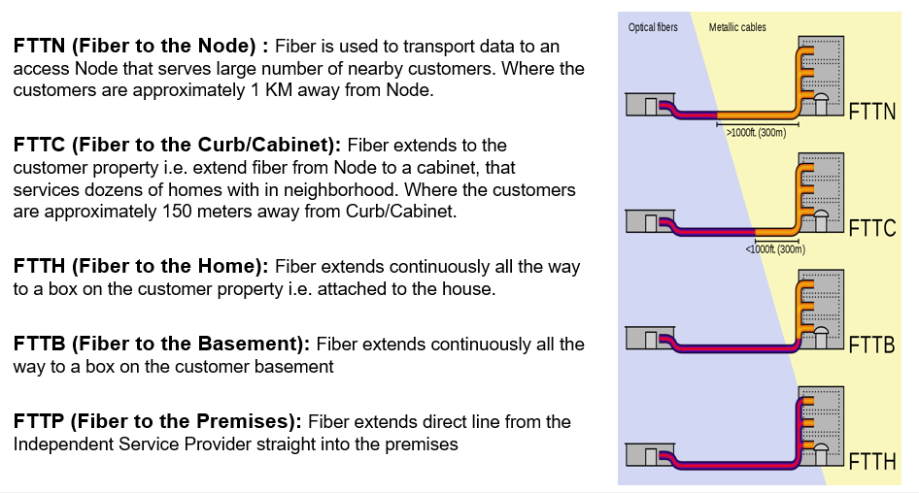

**QUESTIONS**

Answer the following questions. Each question carries one mark unless otherwise noted.

1. What is Telecommunication? Write different type of services you are getting through Telecom.

Telecommunication means transferring signals over a distance. Services that I’m getting are voice, internet, television, networking, and data services.

1. Write down different telecom equipment’s you have seen in your daily life.

Routers, modems, LANs , mobile phones, land phones, television, cables.

1. Write down different ISP network elements from the given example.

ODF, OLT, DWDM, ODF

1. Write the count of following elements exists in the given example. (2 marks)

Pits: ___3__ Poles: _2____

Manhole: ____2___ Conduits: _2____

1. Explain the conditions to use conduits as protection for underground cables?

To protect the cables from damaging. To increase life of the cables. To reduce the wear and tear of cables at high traffic areas.

1. What type of cable is required to get higher speeds in your office - Copper or Fiber?

Fiber Cable

1. Write minimum number of wires require in a copper cable to carry voice and why?

Two wires, twisting the wires together makes it easier to keep the wires close together, and in addition greatly increases the noise rejection.

1. Write ISP / OSP details for the following network features. (2 marks)

PCD: __It is located at the customer location___

SMP: _Splits the signals and amplifies the split signal____

Manhole: _To provide the access to underground cables______

Fiber Access Node: _It helps to provide broadband connection and other data services through a common network box____

1. Can we connect Copper and Fiber cables directly without using any equipment in between? Justify.

No, we can’t connect directly because the transfer speed different.

1. Which technology gives closer Fiber to the customer among all FTTx types?

FTTH

1. Write down all Underground feature’s exits in the given example.

SMP, BJL, FJL, pits, Manholes, Ducted fiber.

1. What is your preferred technology among all FTTx types to get higher speed?

FTTH

1. Cable placed in underground without using any conduit/duct is ____Direct Buried Cables.____________
2. Is Splitter Aerial Sheath (SAS) cable requires protection from Conduit? Justify the answer.

No, because conduit lies underground and SAS lies on the pole.

1. Write down different cable/sheath types, equipment’s, structures exists in ‘Local Fiber Network’ of given example. (2 marks)

Cables/sheath : Aerial Fiber Network (Splitter Aerial Sheath) and underground local Fiber network(Splitter Segment Sheath)

Equipment’s : SMP, poles, SAS, FJL, BJL, SAS

Structures : Manholes and pits.

1. What type of cable/sheath is finally serving to the customer?

Optical fiber.

1. Write down all Aerial network features exists in the given example.

Fiber aerial lead-in(SDS), Aerial fiber network(SAS), Fiber Access Node (ODF, OLT, DWDM, ODF), SMP, Poles.